Name:_________________________________________ Date:___________

Plant Cell Colouring
Cell Membrane (orange)  Nucleoplasm (yellow)  Mitochondria (red)  Vacuole (light blue)  Chromosomes (grey) | Cell Wall (dark green)  Nucleolus (brown)  Chloroplasts (light green) | Ribosome (purple)  Cytoplasm (white)  Golgi Apparatus (dark blue)
Smooth Endoplasmic Reticulum (pink)
Rough Endoplasmic Reticulum (pink)
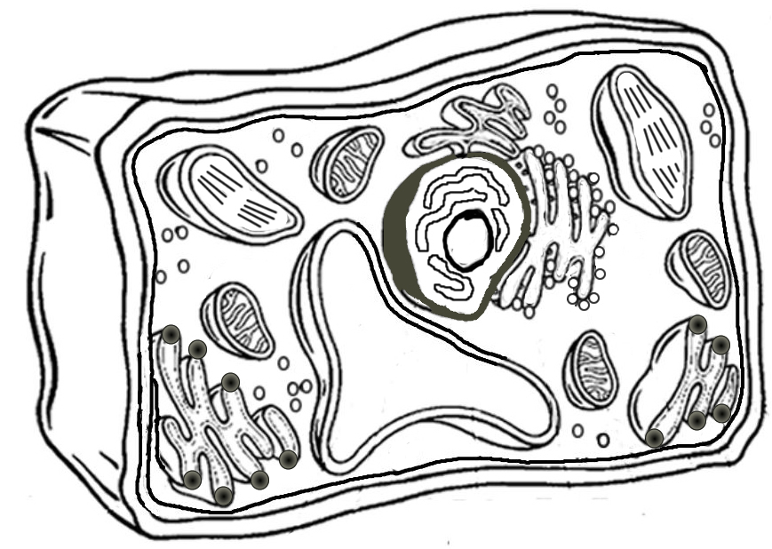

Analysis
- Name two things found in a plant cell that are not found in an animal cell:

- How does the shape of a plant cell differ from that of an animal cell?

- What is the function of the chloroplasts?

- What is the function of the vacuole?

